National University of Computer and Emerging Sciences 

**Laboratory Manual**

*for*

**Operating Systems Lab**

**(BCS-4B)**

| Course Instructor | Dr. Rana Asif Rehman |
| --- | --- |
| Lab Instructor(s) | Mr. Sohaib Ahmed  Ms. Haiqa Saman |
| Section | CS-4B |
| Semester | Spring 2023 |

Department of Computer Science

FAST-NU, Lahore, Pakistan

Page **1** of **5**

Spring 2023

**Tentative Course Outline:**

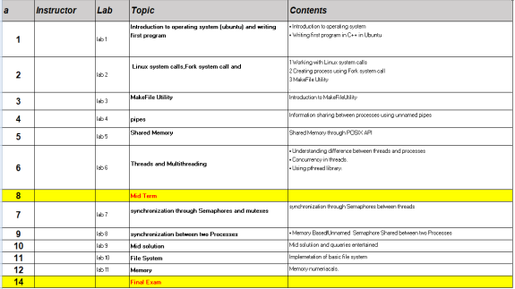

**Tools:**

We will be working in Linux OS. As most of our systems are windows based, we will be using Ubuntu as guest OS. Tools required for lab tasks are:

1. VMware/Virtualbox

2. Ubuntu/fedora(any version)

3. Or WSL can be used too

**Installation:**

You can download virtualbox from the following link:

https://www.virtualbox.org/wiki/Downloads/WindowsHosts

You can download execution file of Ubuntu from the following link:

Page **2** of **5**

Spring 2023

https://ubuntu.com/download/desktop/download/22.04LTS

After downloading both, installation processes starts. You have to view following video to do that: https://youtu.be/v1JVqd8M3Yc

You need to share folder between hosts and guest OS. To do that watch following video: https://www.youtube.com/watch?v=GZBiyKfSTA4

Your installation is done now. Let’s start working!!

**Objectives**

In this lab, students will:

1. Practice Basic commands on terminal

2. Develop a small program in C for reading/writing files

**Basic Commands**

• Clear the console: **clear**

• Changing working Directory: **cd Desktop**

**cd Home**

• List all files in directory: **ls**

• Create a file: **touch filename.extension**

• Copy all files of a directory within the current work directory: **cp dir/\***

• Copy a directory within the current work directory: **cp -a tmp/dir1**

• Look what these commands do

**cp -a dir1 dir2**

**cp filename1 filename2**

**cd ..**

**Compiling C and C++ Programs on the Terminal:**

**For C++:**

Command: g++ source_files… -o output_file

**For C:**

Command: gcc source_files… -o outputfiles

**Example:**

gcc main.c lib.c –o run.exe

g++ q1.cpp -o test

./test

Page **3** of **5**

Spring 2023

**Passing Command Line Arguments to a C/C++ Program**

• Command line argument is a parameter supplied to the program when it is invoked. Command line argument is an important concept in C/C++ programming. It is mostly used when you need to control your program from outside. Command linearguments are passed to the main() method.

• To pass command line arguments, we typically define main() with two arguments: **first argument counts the number of arguments** on the command line and **the second is a pointer array which holds pointers of type char which points to the arguments** passed to the program. The syntax to define the main method is **int main (int argc, char**

**\*argv[])**.

• Here, **argc** variable will hold the number of arguments pass to the program while the argv will contain pointers to those variables. **argv[0] holds the name of the program while argv[1] to argv[argc] hold the arguments**.

• Command-line arguments are given after the name of the program in command-line shell of Operating Systems. Each argument separated by a space. If a space is included in the argument, then it is written in “”.

Page **4** of **5**

Spring 2023

**uestion 1:** (1 marks)

**In Lab Tasks**

See the usage of the following commands online. Also, run them on the terminal. 1. pwd

2. ls

3. cd

4. cp

5. mkdir & rmdir

6. man

7. sudo

8. apt-get

**Question 2:** (2 marks)

a. Create a file named **main.c** and write a code to print “Welcome to BSBS Operating System Lab *Course*” on terminal.

**b. main.c** file contains the main function receiving **command-line arguments.** c. You will pass the name of *Course* via these arguments.

**Question 3:** (3 marks)

• Write a program that takes multiple numbers from the user through **command line arguments.**

• Print the **sum and average** of these numbers on the terminal.

**Question 4:** (4 marks)

• Write a program to copy numbers from one file to another.

• Create a function removeNonAlphabets(char * inputFileName, char * outputFileName) in C.

• This function reads the content of input file and writes only the numbers to the output file.

• The names of input and output files are passed through **command line arguments**. • You can write any alphabets and numbers in the input file.

*Note: You can use any mechanism for file-handling, in this task.*

Page **5** of **5**